BU testte 2 numaralı sürücü devresini 70 kHz’de test ettik. Önceki testlerimizde 58kHzdi. Gate turn on direnci olarak yine 22 ohm var.

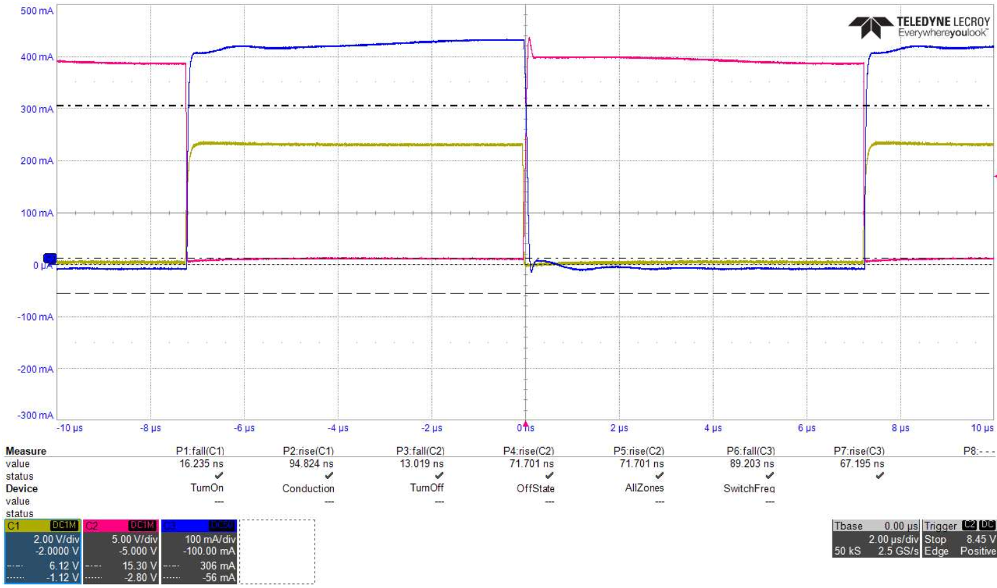

Pembe: Vds=20V Rise Time: 72ns Fall Time: 13ns

Mavi: Ids Rise Time: 67ns Fall Time: 89ns

Sarı: Vgs Rise Time: 95ns Fall Time: 16ns

TURN ON ZOOMED:

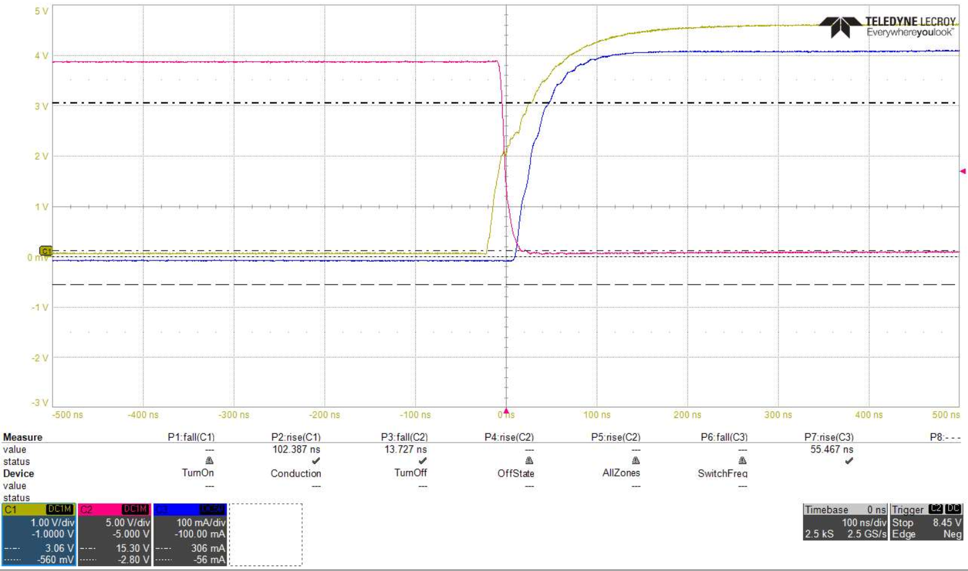

TURN OFF ZOOMED:

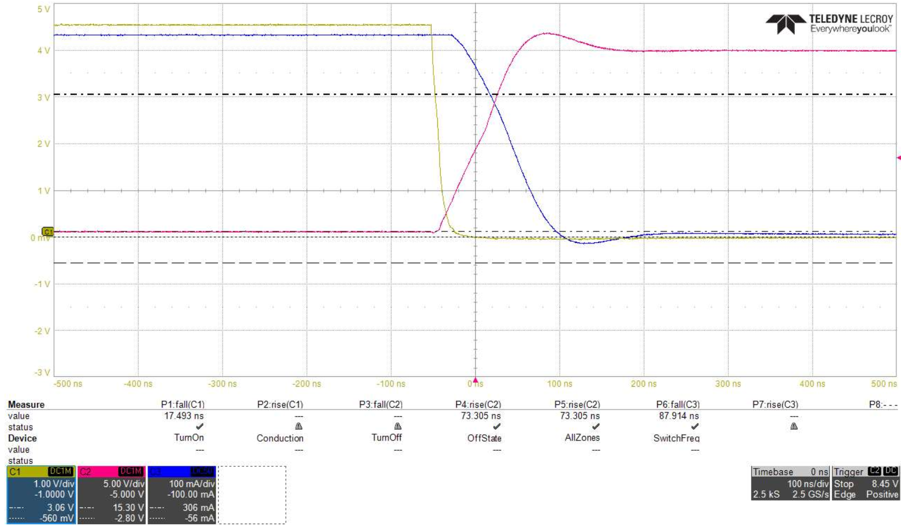

Vds 50 Volt’a çıkarıldı:

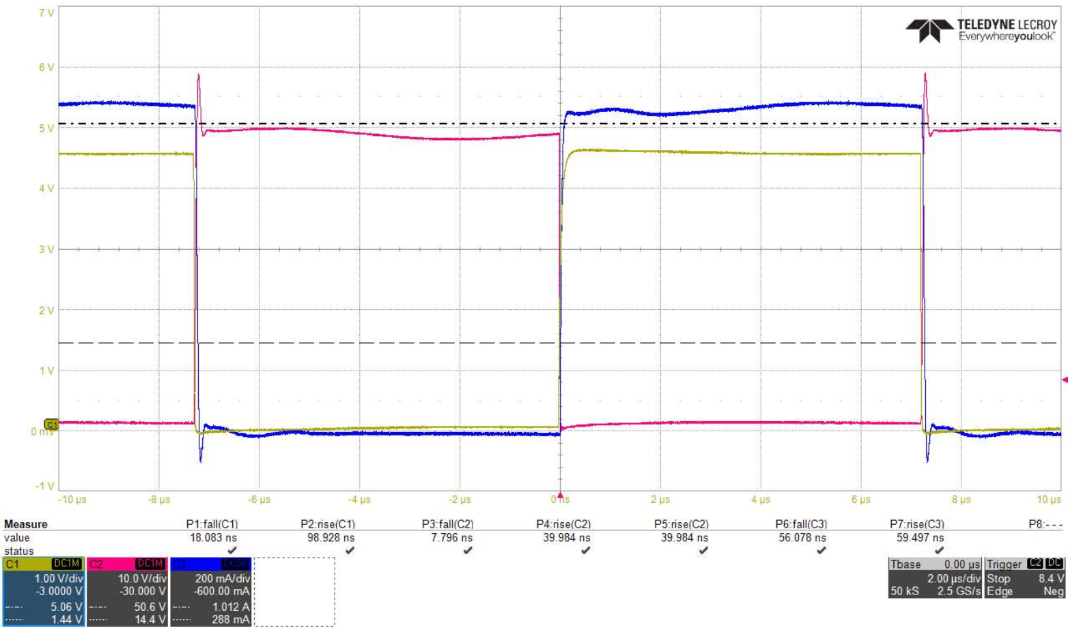

Pembe: Vds=50V Rise Time: 40ns Fall Time: 8ns (Vds=20V Rise Time: 72ns Fall Time: 13ns)

Mavi: Ids Rise Time: 59ns Fall Time: 56ns (Vds=20V Rise Time: 67ns Fall Time: 89ns)

Sarı: Vgs Rise Time: 99ns Fall Time: 18ns (Vds=20V Rise Time: 95ns Fall Time: 16ns )

TURN ON ZOOMED:

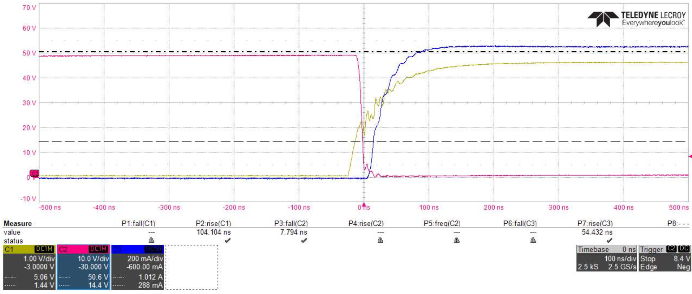

TURN OFF ZOOMED:

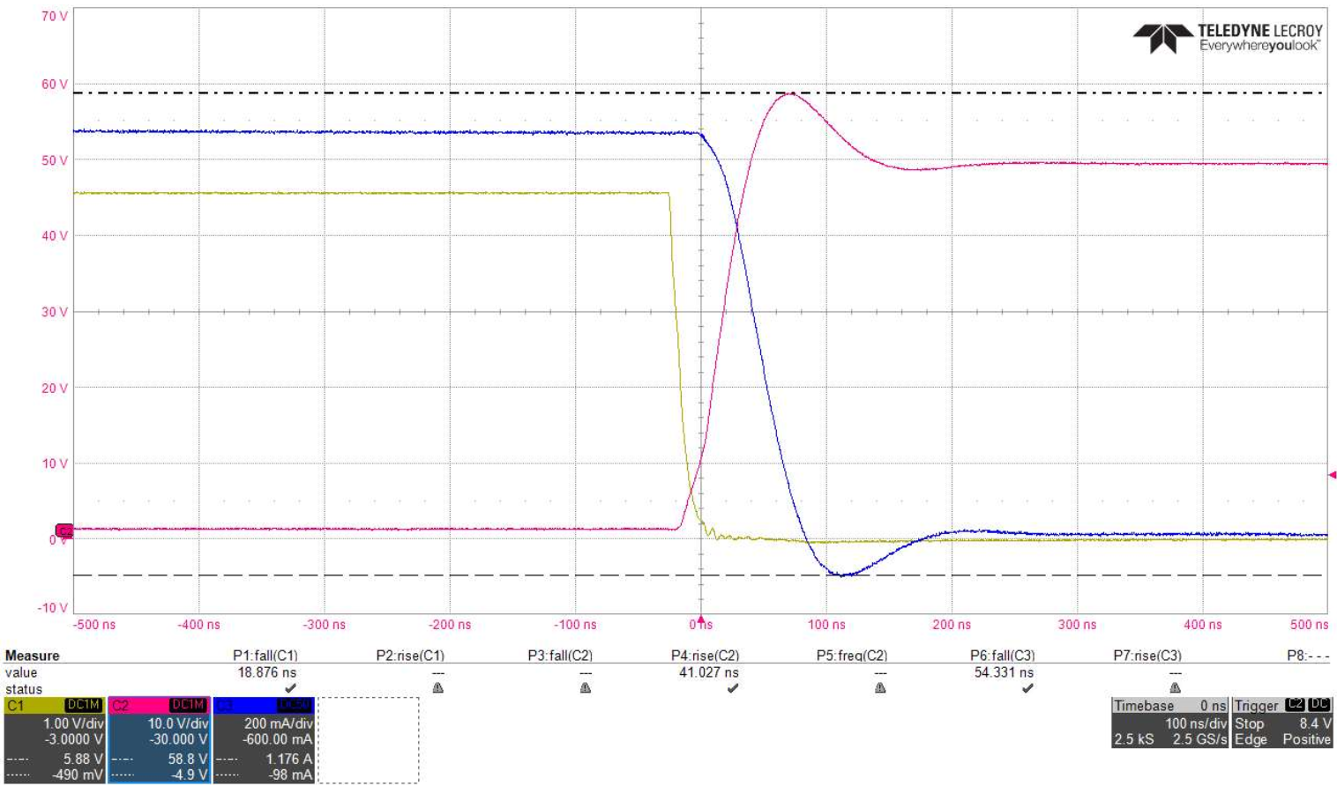

Vds_max= 58.8 @overshoot

Ids_min= 100mA @overshoot

Vds’i 70V yapıyoruz:

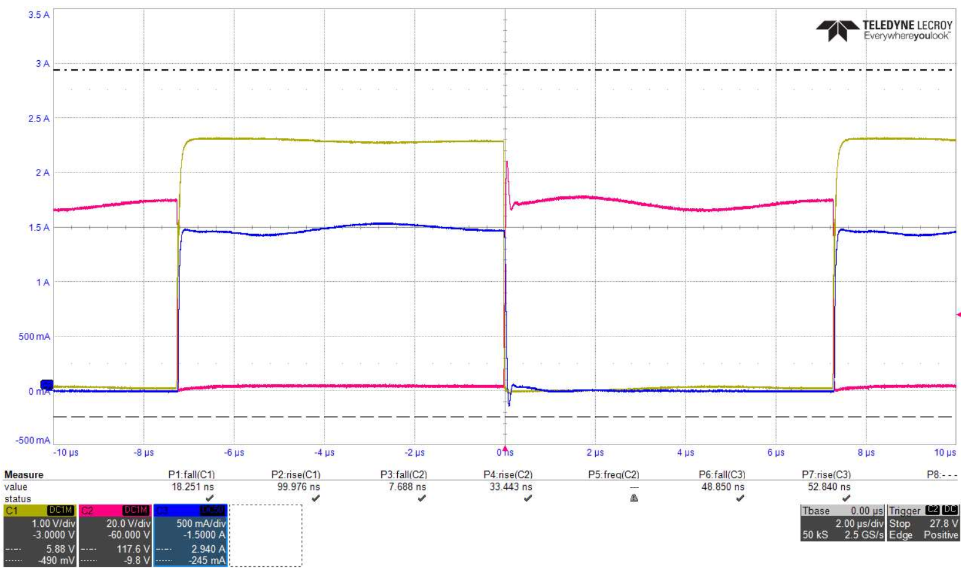

Pembe: Vds=70V Rise Time: 33ns Fall Time: 8ns (Vds=50V Rise Time: 40ns Fall Time: 13ns)

Mavi: Ids Rise Time: 53ns Fall Time: 49ns (Vds=50V Rise Time: 69ns Fall Time: 56ns)

Sarı: Vgs Rise Time: 99ns Fall Time: 18ns (Vds=50V Rise Time: 99ns Fall Time: 18ns )

TURN ON ZOOMED:

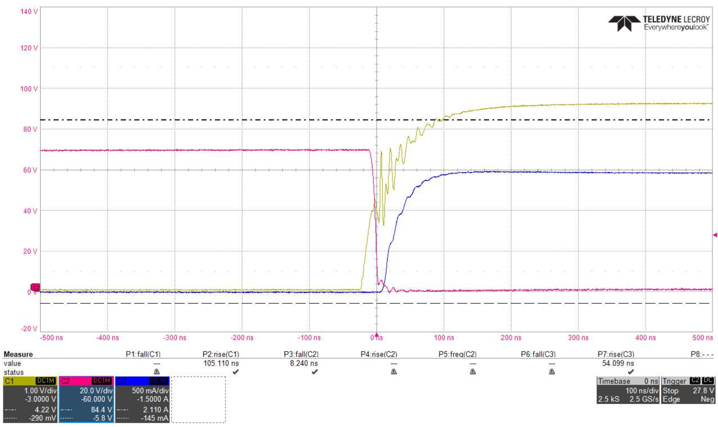

TURN OFF ZOOMED:

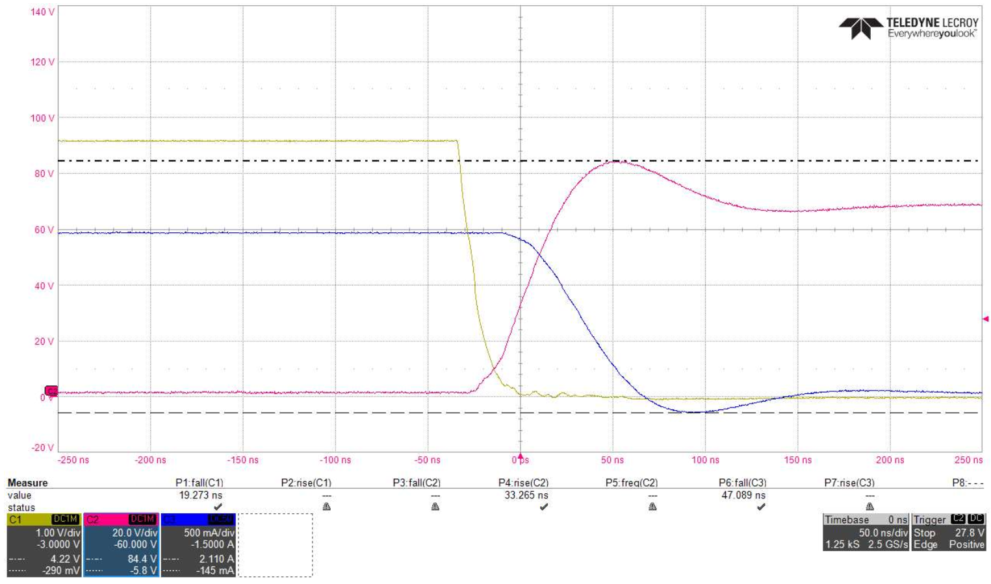

Vds_max= 84.4 @overshoot

Ids_min= -145mA @overshoot

Vds’i 90V’a çıkarıyoruz:

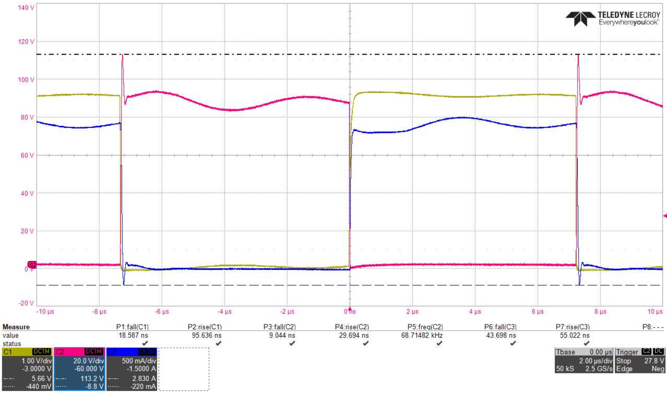

Pembe: Vds=90V Rise Time: 30ns Fall Time: 9ns (Vds=70V Rise Time: 33ns Fall Time: 8ns)

Mavi: Ids Rise Time: 55ns Fall Time: 44ns (Vds=70V Rise Time: 53ns Fall Time: 49ns)

Sarı: Vgs Rise Time: 95ns Fall Time: 18ns (Vds=70V Rise Time: 99ns Fall Time: 18ns )

TURN ON ZOOMED:

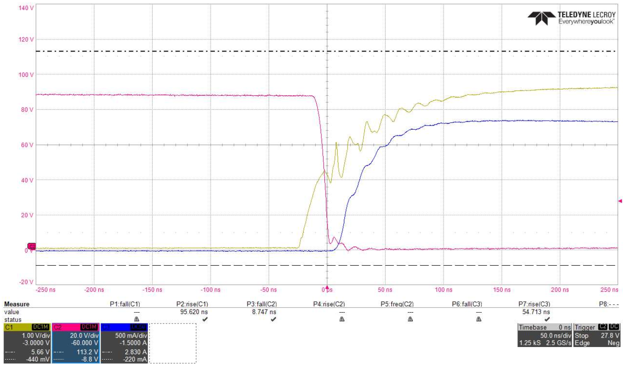

TURN OFF ZOOMED:

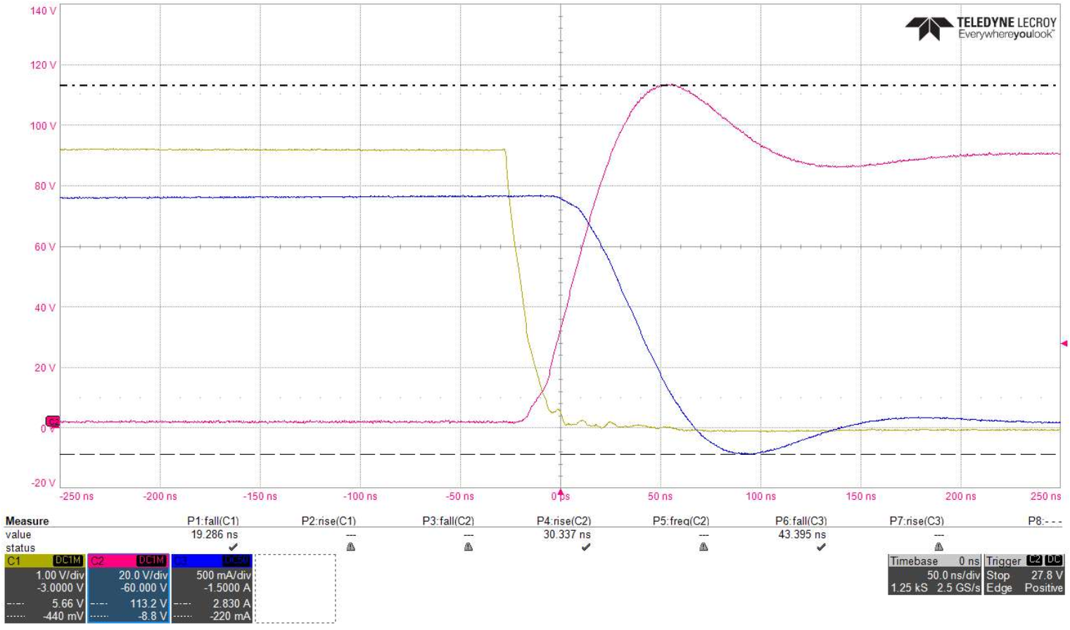

Vds_max= 113V @overshoot

Ids_min= -220mA @overshoot

Vds’i 110 V’a çıkarıyoruz:

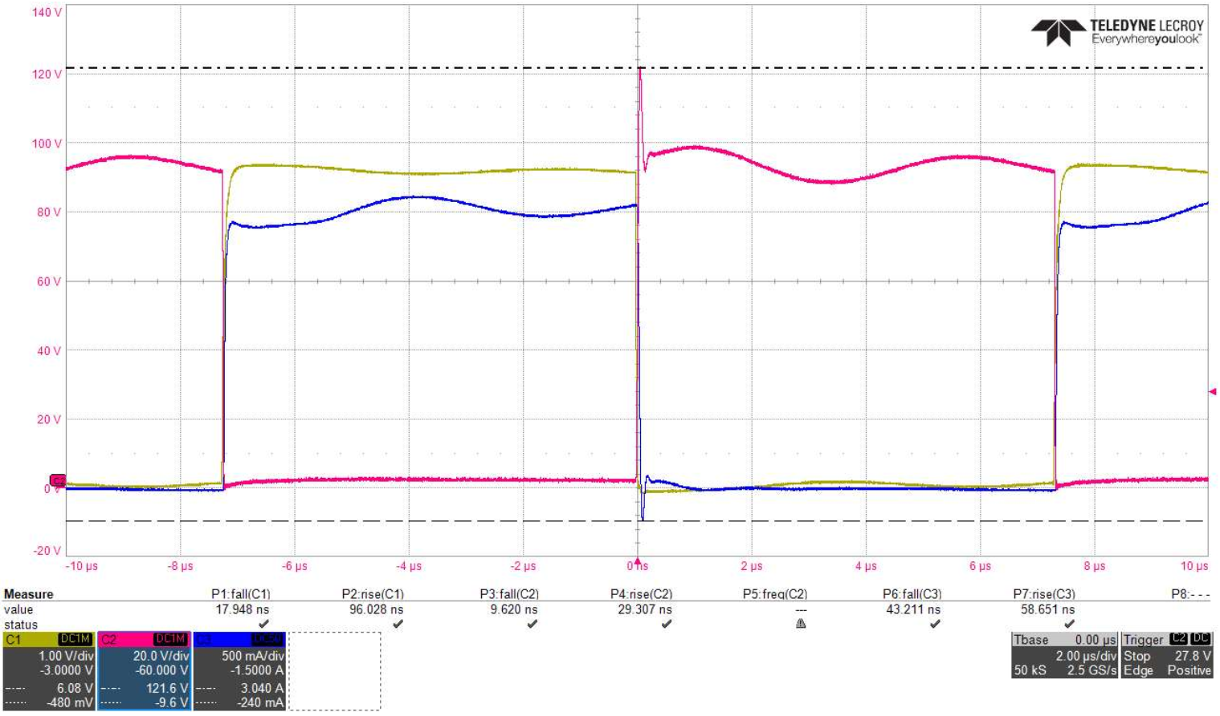

Pembe: Vds=110V Rise Time: 29ns Fall Time: 9ns (Vds=90V Rise Time: 30s Fall Time: 9ns)

Mavi: Ids Rise Time: 59ns Fall Time: 43ns (Vds=90V Rise Time: 55ns Fall Time: 44ns)

Sarı: Vgs Rise Time: 96ns Fall Time: 18ns (Vds=90V Rise Time: 95ns Fall Time: 18ns )

TURN ON ZOOMED:

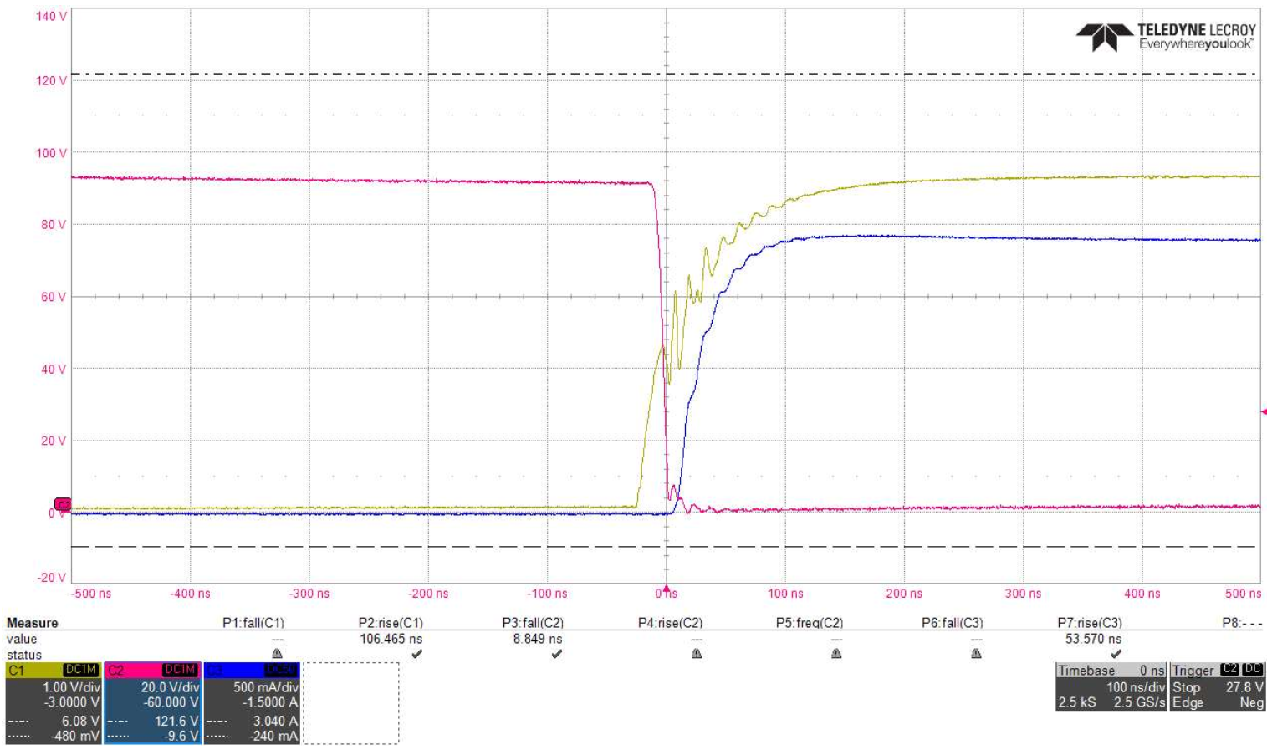

TURN OFF ZOOMED:

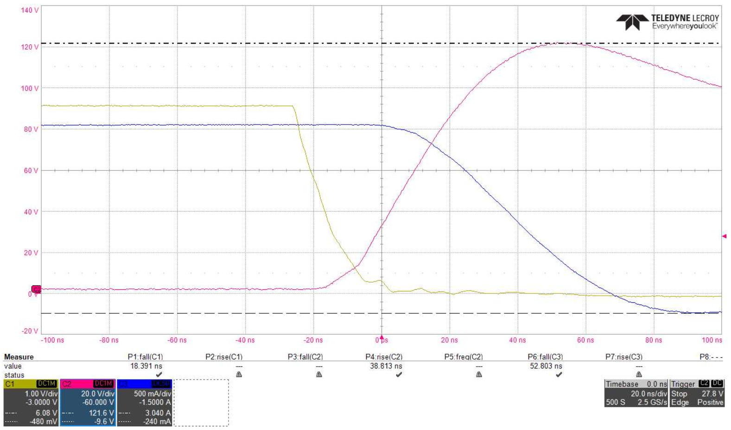

Vds_max= 121V @overshoot %10

Ids_min= -240mA @overshoot

Bu deneyde 70kHz frekansta sonuçları paylaştık. Turn on osilasyonunu azaltmak için sıradaki deneyde gate’e Ferrite Bead takalım. Osilasyona etkilerini gözlemleyelim.